**Lab Practical #8:**

Study & Survey of Institute organization network infrastructure.

**Practical Assignment #8:**

1. **Identify type of network in your institute. Draw a design of network in your institute (Any Lab/Floor/Building).**

**Lab NO.: C-209**

**Topology: Star Topology**

All devices are connected to central switches, ensuring easy management.

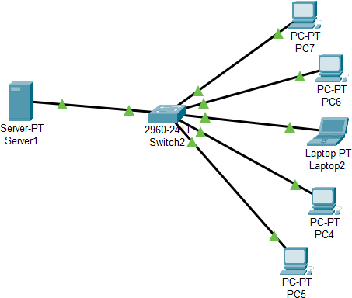

1. **List how many network devices and types of cable used and give its details.**

* **Total No. of PC:** 9, Used by students and staff for accessing network resources and internet.
* **Total No. of Switch:** 2, Central devices in the star topology that connect PCs and server together.
* **Total Server:** DHCP Server, Assigns dynamic IP addresses to all connected devices in the LAN.
* **Types of Cables:** Twisted Pair Cable, used for Ethernet connections between PCs, switches, and server.
* **Connectors:** RJ-45, Standard connector for twisted pair cables in LAN setups.
* **Network Type**: LAN, Enables fast and secure internal communication.